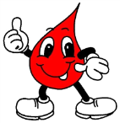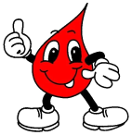How old do you have to be to donate in NY? **16**

O– (Universal Donor) 0+ AB+ AB- B- B+ A+ A-

1 pint of **blood** is removed! Your body will start to regenerate the **blood** back *immediately*!

Where does your body regenerate blood? ***Bone Marrow***

You should eat & drink before donating blood

& afterwards you will be feedand hydrated!!!!

Have to weigh at least **110 pounds**!

If you are sick, you cannot donate



One donation **saves** up to **3** *lives*!