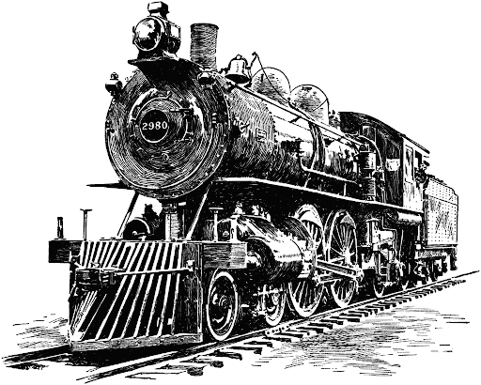

# Course Syllabus

**Roy C. Ketcham High School**

**Social Studies Department**

**Global II**

**2022-2023**

## Instructor Information

Instructors: Mrs. Johnson

Room Location: Room 105

E-mail: [jessica.johnson@wcsdny.org](mailto:jessica.johnson@wcsdny.org)

Extra Help Time: By appointment

## Course Identification

Course Number: D447

Course Name: Global II

Course Location: Room 105

Prerequisites: Global I

## Course Description/Overview

The Social Studies program for 10th grade is Global History. The purpose of this course is to help students gain an understanding of themselves as members of a global community. Through the examination of diverse world cultures, students will come to appreciate both their heritage and that of other peoples. By studying the past, with emphasis on major themes and developments in history, students will gain a clearer understanding of the present day, and make educated and responsible decisions for the future. The chronologically developed units of study begin in September with the world in 1750 and culminate in June with current global events. Students will also apply their knowledge and skills to the New York State Global Regents Exam, taken in June of sophomore year.

### Course Website(s)

* [**https://www.wappingersschools.org/cms/Workspace/Section/Section.aspx?DomainId=1477**](https://www.wappingersschools.org/cms/Workspace/Section/Section.aspx?DomainId=1477)

### Required Course Text

* [Textbook-World History - Mr. Duncan's History Page (weebly.com)](https://mrdseatech.weebly.com/textbook-world-history.html)

### Course Supplies

* A 3-ring binder (no preference), looseleaf paper, and plenty of writing utensils (pencils or pens).

## Course Learning Objectives

Upon successful completion of this course, students will be able to:

* compare and contrast past events and current issues
* write an Enduring Issues essay for the Global History Regents Exam, taken in June of sophomore year
* identify recurring themes in history
* develop and organize argumentative papers on historical topics.

### Grading Policy

Grades will be based on the following:

| **Course** **Component** | **Percentage** |
| --- | --- |
| Classwork | 10-20% |
| Homework | 10-20% |
| Quizzes | 30% |
| Tests/Essays | 40% |
| **Total Points** | **100%** |

### Late Assignments

* Students receive full credit (100%) on an assignment if the student was not in class due to illness or other legal absence.
* Assignments are accepted for half-credit (50%) one day after the original due date. After this, the assignment drops to 10%.
* Students are expected to complete all posted homework assignments if absent from class in a timely manner.

## Course Policies

* Class rosters are provided to us with the student’s legal name. We will gladly honor your request to address you by an alternate name or gender pronoun. Please advise us accordingly early in the school year by the manner in which you feel comfortable (speak to us privately after class, email, etc.) so that we may make appropriate changes to our records.
* It is our goal to promote an atmosphere of mutual respect in the classroom. Please raise your hand when you wish to speak or ask questions, please do not speak when others are speaking, please speak to each other in a respectful manner, etc. Foul language and inappropriate behavior are not tolerated.
* Everybody has to use the bathroom! When you wish to go, please ask first and then use the soap up front.
* Seating will be at the discretion of the educator and seats will be reassigned every five weeks.
* Cellphones, earbuds and other electronic devices are not permitted to be used in class. The focus of class time should be interaction between students, and with the educators. Any other unauthorized activities are likely to be distracting to other students and the educators, and you will be asked to please put it or them away.

## Academic Integrity Rules

* Students may discuss homework assignments, but are expected to individually work/write/solve any and all submitted work.
* All authorized resources used, including but not limited to internet sites, should be appropriately cited.
* Plagiarism means submitting work that somebody else wrote, copying passages (sentences, paragraphs, or phrases) that somebody else wrote without citing the source (where you got it from), or turning in work that you wrote for another class. Any or all of the above will result in your assignment receiving a zero for a grade.
* Please check your Google Classroom daily, as you are responsible for completing the posted assignments - assignments are graded on a percentage basis and notes will not be posted until the end of the unit.
* Extra credit may be offered on certain assignments, and there are also separate extra credit assignments from time to time throughout the marking period.
* Students can always ask questions pertaining to their grades, extra credit, or ways to improve their academic performance.