___/50

Name:_________________________________________ Date:____________ Period:_______

Directions: Using your previous knowledge and skills from Adobe Illustrator, Photoshop, and Flash you will be broadcasting the weather as a Flash animation. Your final Flash file will be exported as a Flash Movie File to be played on High Definition Television.
Document Information & Constraints:
Step One: Making Folder
Make a New project folder labeled _ _ weather

Step Two: Setting Up Flash Document
- Launch Adobe Flash
- Create a new ActionScript 3.0 file (AC3)
- Setup your stage Size 600 (width) x 350 (height) in Pixels
- Save Flash file as _ _ weather.fla

Step Three: Weather Forecast Communicated
- Must convey three different pieces of information (see ideas and circle below):

  - Day’s High and Low
  - Sunrise and Sunset
  - Humidity
  - Percentage of Precipitation
  - Warnings and Advisories
  - Wind Speed
  - Weekend/Daily Outlook
  - Wind Chill
  - Traffic
  - Smog & Fog
  - Allergy
  - Interactive Maps

Step Four; Shopping for Media
- Using Microsoft Office Clip Art Gallery or Vecteezy.com
  - Launch Microsoft Word’s Clip Art Gallery (Insert ➔Clip Art ➔Clip Art Gallery) Choose “Online” to launch online searchable image gallery
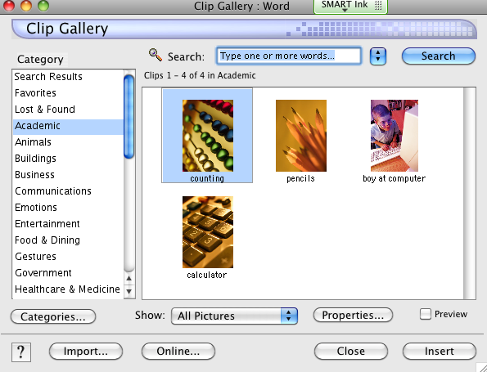

  - Using the Microsoft Online Clip Art Gallery, search for images related to your Flash weather project (ex. clouds, sun, rain, tornado, lighting)
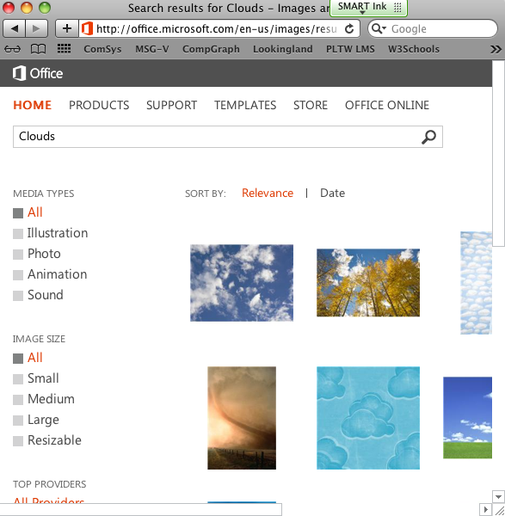
  - Filter selections by “Resizable” to limit searches to Vector Graphics, this will flow you to edit your graphics in Illustrator.
  - Save all graphics in your newly created Weather project folder (Step One)
Step Five: Editing and Creating Images in Adobe Illustrator
- Open your downloaded resizable vector and clip art files in Illustrator.
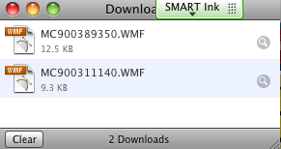
- New Documents should be set to Video & Film (see example below):
- Save your Illustrator files in your newly created Flash project folder.

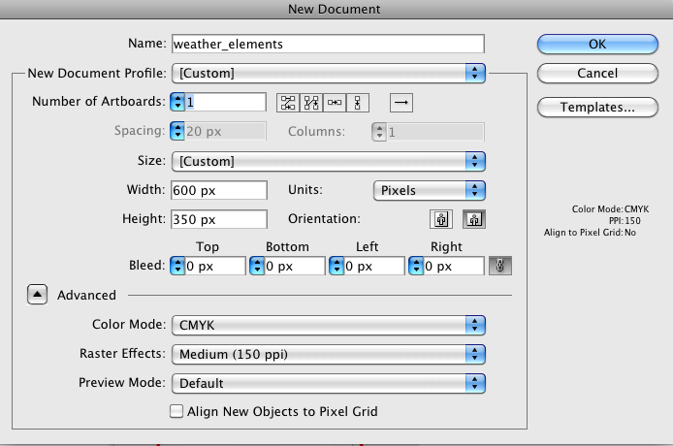
Remember:
Your Movie Size is:
600 pixels wide
350 pixels tall



Step Six: Importing Media into Flash Library
- Choose File → Import → Import to Library
- Graphics may need to be converted to symbols
  - Modify → Convert to Symbol (F8)

Step Seven: Begin Creating your Weather Movie
- Utilize and organize files into library
- Utilize and label layers
- Preview movie frequently
- Use proper tweens for your movie
- Constantly SAVE your work as you complete this project

Step Eight: Add Sounds and Music
- What are some of the sounds do you need to enhance your weather movie?
- Refer to Sound Resources in Flash Note Sheet
- Download sound files from a reliable sound website into your project folder
  - WWW.FLASHKIT.COM
  - WWW.FINDSOUNDS.COM
  - WWW.FREESOUND.ORG
  - Research your own resources

Step Nine: Save and Publish Final Movie
- File → Export → Export Movie
- Save your file in your Flash Weather Project Folder as a .SWF file.
- File Share your project folder containing raw flash files, exported video, and supporting graphics, sounds, and etc…

Grading:
Proper File Structure and Naming _____/10

Imported Imagery from Illustrator _____/10

Animations Play smoothly _____/10

Three Different Elements _____/10

Technical _____/10

TOTAL: _____/50

