Name:___________________________________________________ Period:___________

Introduction:
As part of Communication Systems, you will lean about audio communications and how to effectively work with audio. Audio is an integral part of any system of communications, whether it’s a movie, commercial, song, or a simple public service announcement. Audio could “make” or “break” or final production, so it’s important you learn and understand this key component.

Directions:
You will be making a 60 second (exact) audio mix using your own audio samples. You must have a sample of music before you begin this project.

Step One: Burn Music
Make a playlist to burn on a CD of 8-12 songs. iTunes is a free download (www.iTunes.com) which will help you manage and burn your playlists to CD. Keep in mind, sometimes your favorite songs do not always mix or blend well with others. TIP: 80’s Music seems to work well.
Burn 7-10 Songs in AIFF
(Audio Interchange File Format)
Step Two: Setup Project Folder
Make a new project folder in your current Communication Systems folder. Label this folder _ _ (first & last initial) audio_mixing. Example, jb_audio_mixing

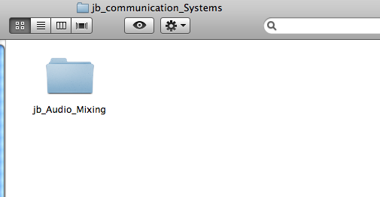

Step Three: Import CD Audio Tracks
Place your CD into your computer workstation and drag your audio files from your CD into your newly created audio_mixing project folder. Once your files transfer from your CD into your folder, eject your CD, you will no longer need your CD. You can eject your CD by dragging your CD to the trashcan, which will turn into an “EJECT” icon. TIP: It’s quicker if you drag files off your CD one at a time. Dragging all files at once will take longer.

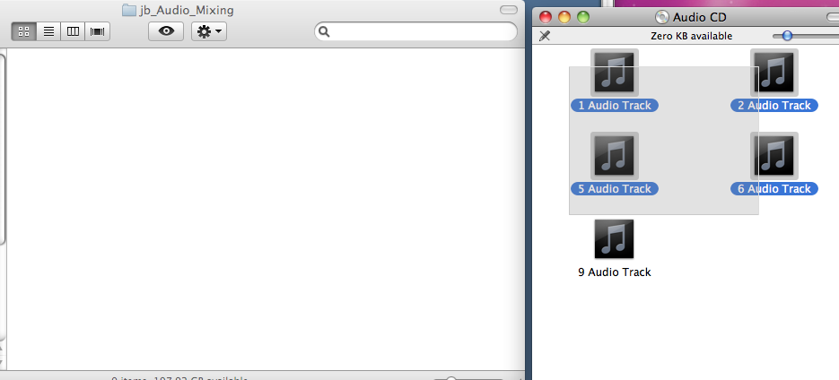
Drag Audio Tracks from your CD to your Audio Project Folder.

Step Four: Setup Sound Studio
Open Sound Studio. Once your program loads, save your new blank audio files as _ _ (first & last initial) audio_mix and save this in your previously created audio mixing folder.

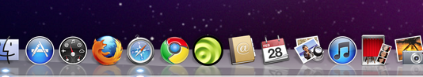

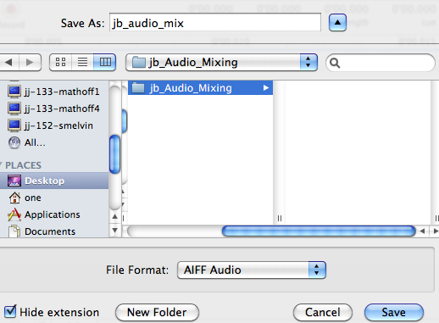

Step Five: Open Imported CD Tracks
You may begin opening your previously imported audio files (tracks) into Sound Studio. Choose File → Open to navigate to your Audio Mixing project folder to select your audio tracks.

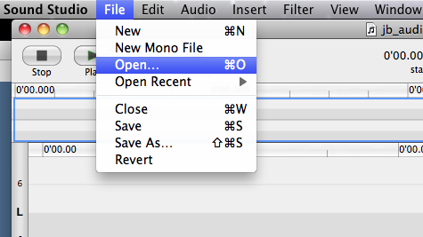

Step Six: Edit and Mix Music
Copy and Paste selections of other tracks into your Audio_Mix track. Make sure you are pasting your tracks into your newly created Audio_Mix file. At this step you will be spending most your time cutting, copying, and pasting your audio files. This step will take the most amount of time. Remember your final file will be 60 seconds in length.

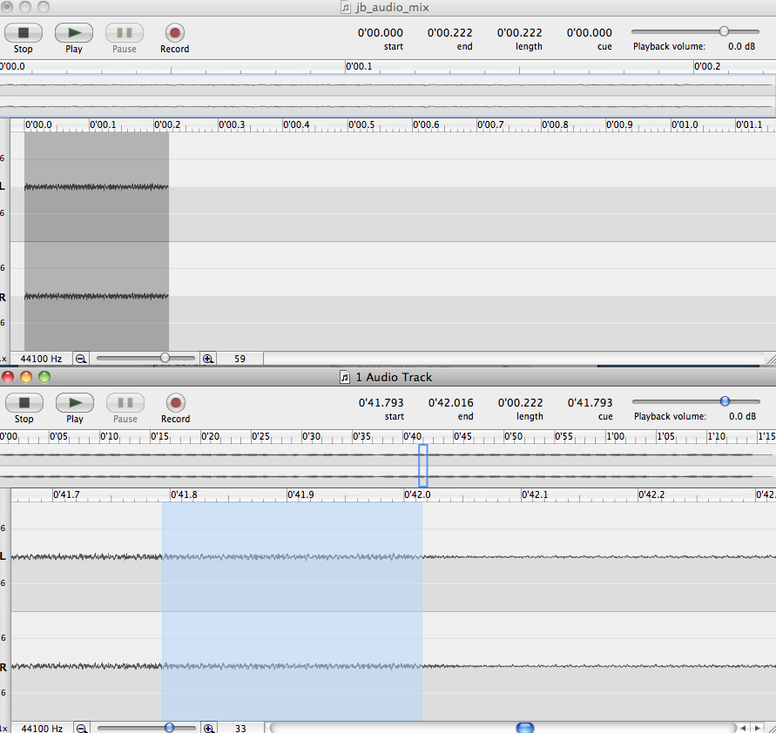
Copy
From Track File

Paste on
Mix File

Frequent Shortcuts:
C (Copy)
V (Paste)
X (Cut)
M (Add Marker)
Z Undo/Step Backward

Step Seven: Fades
When finished with your mix, Add a 5-second Fade-In, and a 5-second Fade-Out.
- Simply highlight the first 5-seconds of your track and choose Filter →Fade In, repeat for the last 5-seconds Fade Out

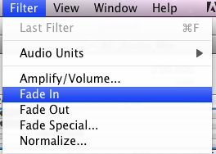

Step Eight: File Share
File Share to JJ-167-Teacher. Refer to Notes on File Sharing.

Grading Rubric:

Is the mix 60 seconds in length? ____/5

Do you have a 5 second fade-in and fade—out ____/10

Did you incorporate audio filters? ____/10

Does your mix utilize appropriate blending techniques ____/10

Is your music something that could be utilized on radio? ____/5

Total: ____/40

