**___/70**

Name:________________________________________________________ Period:_________

**Introduction:**

*After learning (Adobe Photoshop Lessons) skills, creating and altering graphics using Photoshop, you will apply your previous knowledge to complete one of the project options below. Please Note: some research is required to ensure optimal results are achieved!*

**Step One: Choose a Project Design Challenge Below** (Circle One)

**Option A: Zombie Self Portrait**

* Using the ComLab Green Screen, you will take a photo of yourself
* 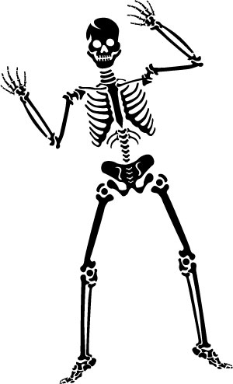Begin Researching Zombie or other creature-like Photoshop tutorials.
* Design a background to match your self-zombie portrait

**Option B: Creepy Places**

* Create a computer graphic of a creepy place or places
* Utilize Photoshop filters and styles to enhance the creepiness
* Download fonts and utilize type effects in your work

**Option C: Halloween Postcard/Advertisement**

* Create a postcard or advertisement for a Halloween function
  + Hayrides, house party, ghost walk, upcoming even
* Utilize text, filters, and styles to enhance your work

**Option D: Halloween Movie Trailer Poster**

* Using online high quality graphics to create a movie trailer poster
* Utilize text, filters, and styles to enhance your work

**Step Two: Creating a New Project Folder**

* Make a new folder in your Computer Graphics folder
* Label this folder _ _ (first & last initial) halloween_graphic (jb_halloween_graphic)

**Step Three: Sketch Two Possible Ideas for your Project**

**Step Four: Browse the Web for Photoshop Special Effects**

* Search (by Googling) Photoshop special effect tutorials
* Bookmark Useful tutorials and refer back for future use.

**Step Five: Search and Import Graphics**

* Take digital photos using the green screen and digital camera
* Using your SD card reader, import the images you took into your project folder
* Search the Internet for HIGH RESOLUTION photos that you may want to use in your final project.
* Label each photo and organize into your project folder.

**Instructor Signature:**

**_________________**

-------------------------------------------------- **STOP & SHOW YOUR INSTRUCTOR** ----------------------------------------------

**Step Five: Setup a new Adobe Photoshop document**

* Start Adobe Photoshop and set up a new document
* Document Properties
  + 5 x 7 inches (width and height dimensions will vary on portrait vs landscape)
  + 300 Resolution
  + RGB Color Mode
* Save your newly created Adobe Photoshop document in you project folder as *_ _ (first & last initial) halloween* (jb_halloween.psd)
* Import your images into Photoshop
* Label your image layers
* Stylize your text (Remember to SAVE FONT FILES in your project folder)
* Made sure the overall poster is visually appealing using the Principles & Elements of Design.

**-------------------------------------------------- STOP & SHOW YOUR INSTRUCTOR ----------------------------------------------**

**Instructor Signature:**

**_________________**

**Step Six: Flatten, Save and Print your Completed Poster**

* Finalize any last minute changes by Saving
* Choose **File → Save As** and save a copy of your poster as *_ _ (first & last initial) halloween_flat* (jb_halloween_flat.psd)
* Choose **Layer → Flatten Image** to merge all layers together and reduce file size.
* Choose **Image → Color Mode→ CMYK**
  + CMYK is our color mode specifically for printing
* Choose **File → Print**
  + Make sure you select the proper **page layout** option
  + Make sure you select the proper **paper feed** option

**Step Seven: File Share**

* Copy and Paste your project folder in the Completed Drive for grading

--------------------------------------------------------------------- **GRADING**-------------------------------------------------------------------

**File Folder Structure _____/5**

* Did you save and label your files correctly?
* Do you have all images and working Photoshop files in your project folder?

**Photoshop Technical _____/10**

* Did you label all layers?
* Is your image correct size, resolution, and color mode?
* Did you flatten and convert to CMYK?

**Creativity _____/20**

* Does your poster utilize the Principles & Elements of Design?
* Did you effectively use a variety of Photoshop tools in your graphic?
* Is it evident you researched online tutorials in your final graphic design?

***Photoshop was the death of me!***

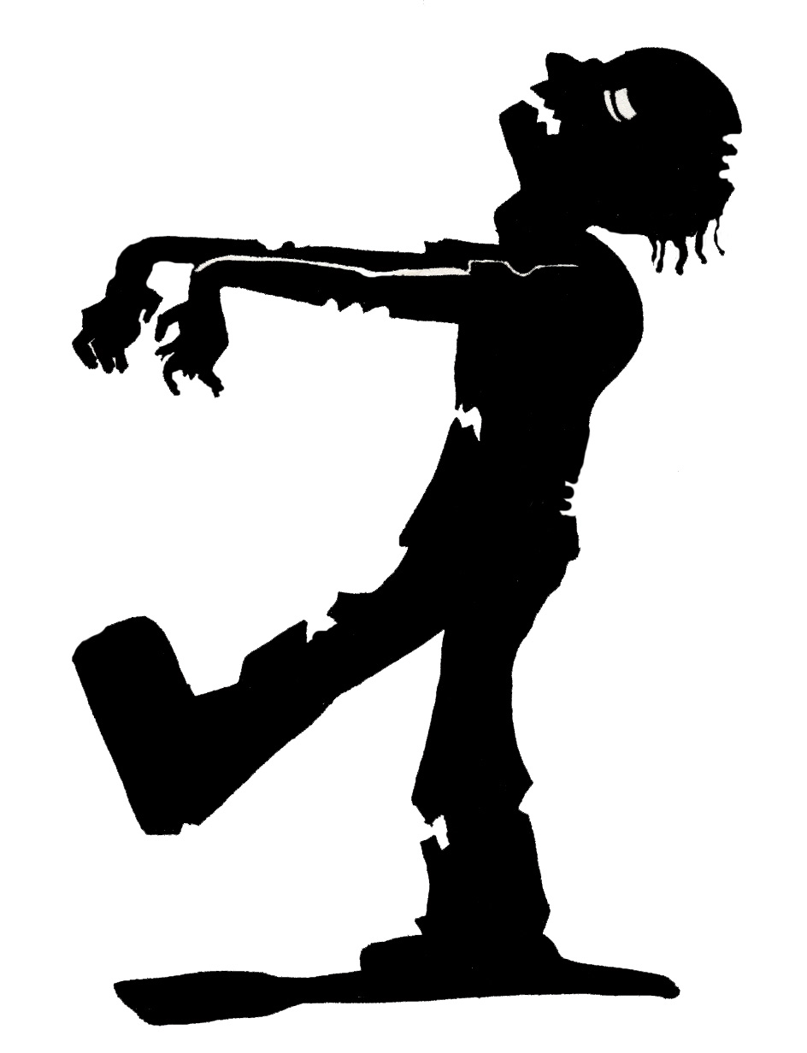

**TOTAL: _____/35 x 2 = _____/70**