Name: ________________________________________________

Listed below are “usable” resources that can be legally used in your video production projects and assignments. Make sure you save these audio files in the correct format and in the correct files.

Free Play Music
URL: www.FreePlayMusic.com
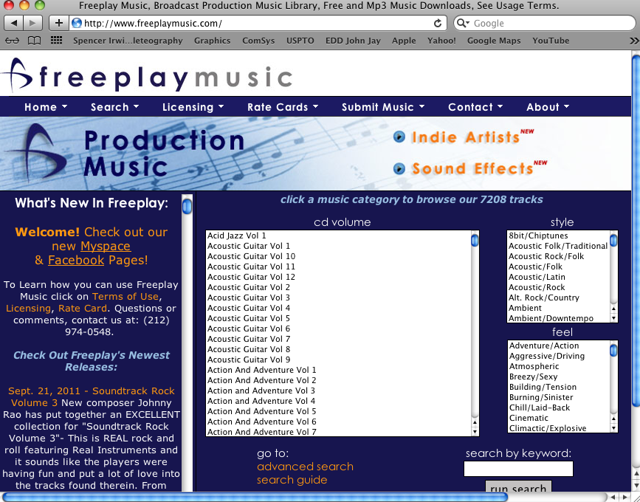
- Music can be previewed in iTunes and Downloaded in iTunes

Position Music
URL: www.PositionMusic.com
username: jeffrey.butler@wappingersschools.org
password. msgvarsity84
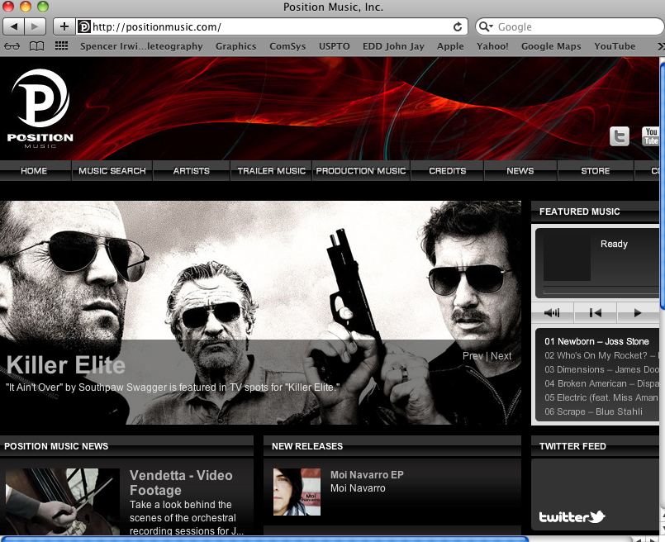
- After navigating to this website, sign-in using the username and password provided at the top section
- John Jay is limited to the Production Music and Trailer Music libraries only.

Flash Kit - SoundFx
URL: www.Flashkit.com
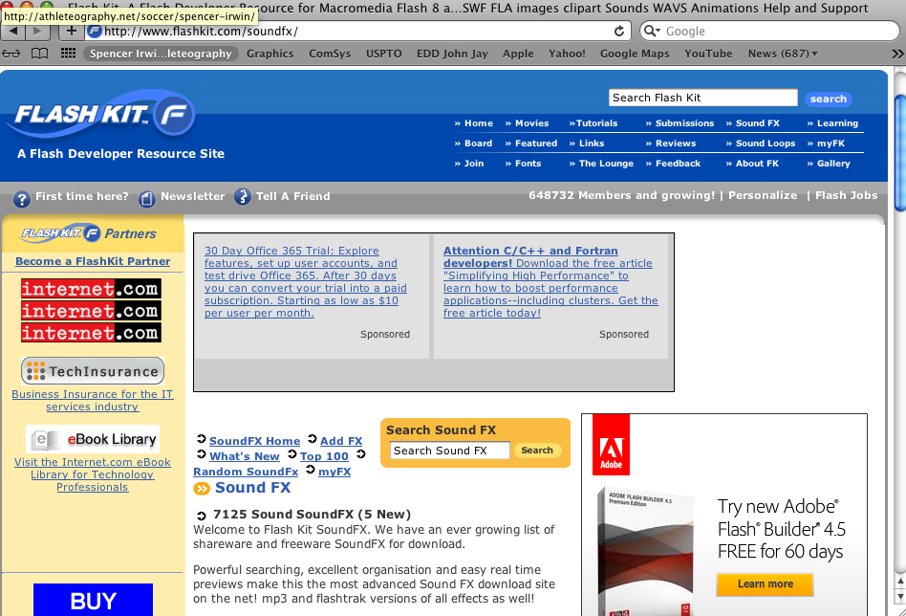
- Choose the “Sound FX” tab and browse sound FX libraries

