Activity 3 – Making Effects in LiveType (Assignments)

Communication Systems
John Jay High School

Department of Technology Education Mr. Butler

Name:_________________________________ Period: ___________

Apply an Effect to Text
Type your Name into the Inspector window, and apply an Effect to your text.
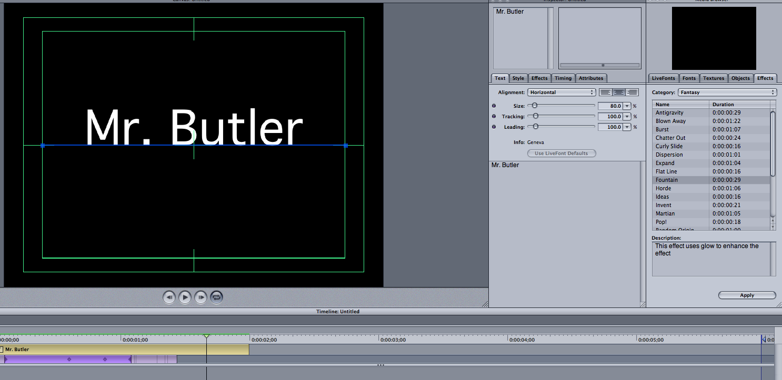

Adjust Timing
In the Inspector pallet, choose the TIMING tab. The timing tab allows you to change settings to your text animation. NEVER DRAG THE TIMELINE SLIDERS IN THE TIMELINE WINDOW.
Sequence: Changes the rate at which your characters animate into your canvas area.
Speed: How fast or slow the duration of your animation is.
Delay: Determines when your animation starts, you can type in a negative value (-.04), which will start before the timeline begins.
Loop: Determines how many times your animation takes place within your timeline.
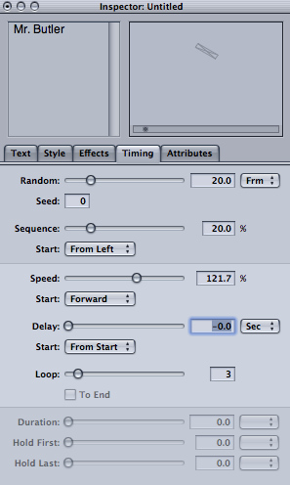

Changing Attributes of Individual Letters
In LiveType you can change the individual Attributes of each individual letter within your animation.
Click on your track in the timeline, NOT the effect. With the track selected, select any single letter in your name.

In the ATTRIBUTES tab of the inspector pallet you can choose a color and apply it to the single letter you selected.
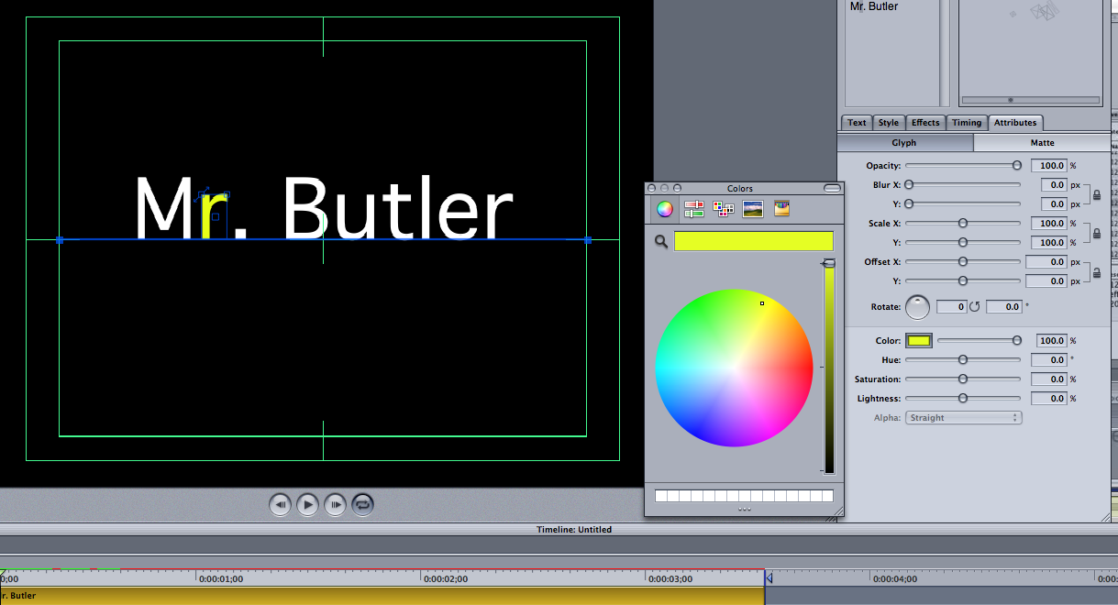

Applying Effects to a Single Character
To apply an effect to a single character select a letter and choose an effect from the EFFECTS tab in the Media Browser. Choose APPLY. That one particular character has an effect attached to it.
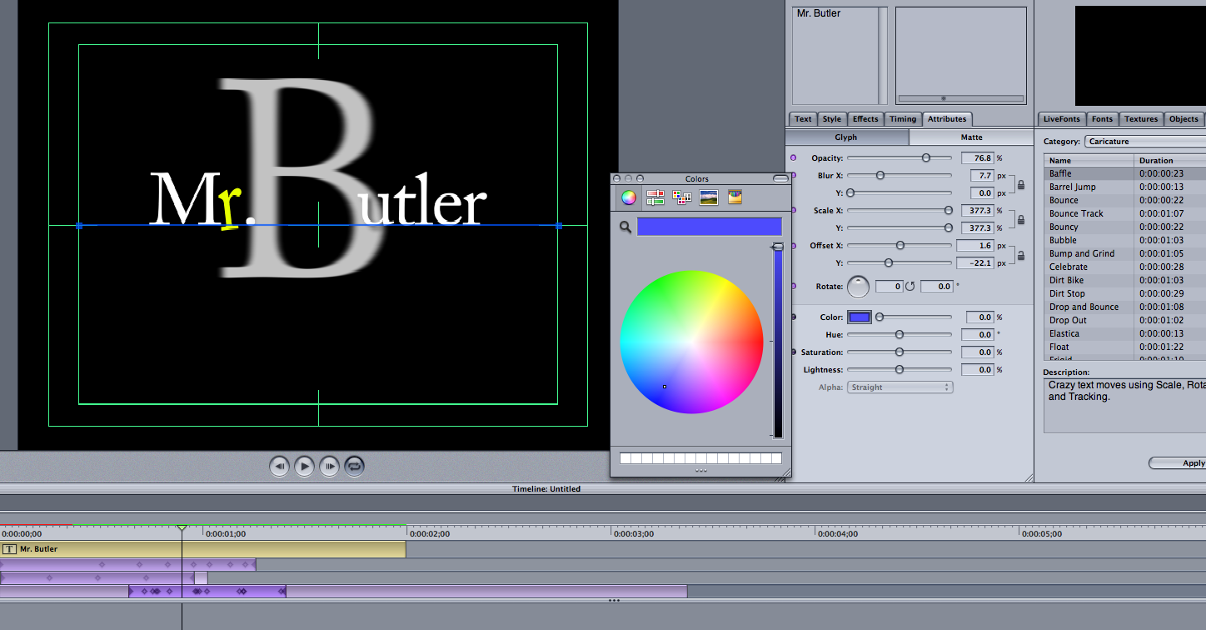

Deleting Effects
To delete an applied effect, simply click the effect in the Timeline and press Delete. To Change your letter back to the original color simply choose that letter and choose the proper color in the ATTRIBUTES Tab.

Changing Animation Timing
To change the rate at which each character animates can me accomplished in the TIMING Tab of the Inspector Pallet.

Click on the animation in the Timeline and then slide the Sequence slider in the TIMING Tab. Fell free to adjust other settings in the TIMING Tab such as Random, Seed, and Start.

In LiveType make a new canvas. Name this file as __ __ (first & last initial) Activity3, and SAVE this file in your Activities folder located in your Project V folder.

After Completing Activity 3, you will:
- Type John Jay on White Background
- Add an Effect to the word John Jay
- Alternate the letters in John Jay from Dark Blue to Light Blue (every other letter)
- Add another Effect to only the Light Blue Characters
- Adjust Timing Properties accordingly

When Complete, call instructor over for approval:

_________

