Activity 1 – Creating Titles in LiveType (Assignments)

Communication Systems
John Jay High School

Department of Technology Education Mr. Butler

Name:_________________________________ Period: ___________

Starting LiveType
Start LiveType Located on your Dock.

Setting up Project Properties
In LiveType, choose Edit → Project Properties.

In Project Properties you can change the project video presets, background color, opacity, show grids & rulers, as well as render background. Make sure you check the box next to render background.

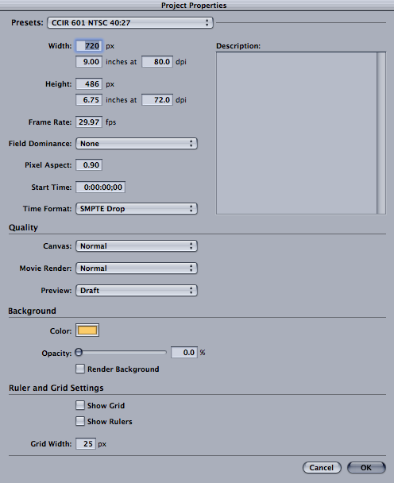

Adding Text with Inspector
In the Inspector pallet TEXT TAB you can add text in two ways. You can also make other adjustments

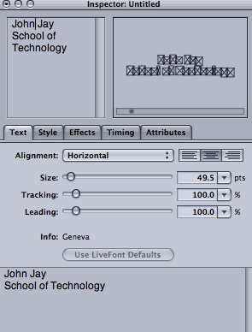

Size, Tracking, Leading, and Alignment
In the TEXT TAB you can adjust by moving sliders or inputting numbers into the data fields.
Tracking: Space between characters (letters)
Leading: Space between words

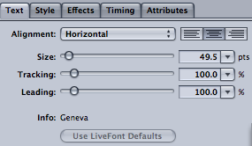

Adjusting Track Curve and Control Points
In your canvas area you can adjust the curves and points of your text by clicking on and individual character or a group of characters.

To add a control point, right click on your Track Curve and select Add Control Point.

To reset your track (blue line) choose Layout → Reset Track Curve.

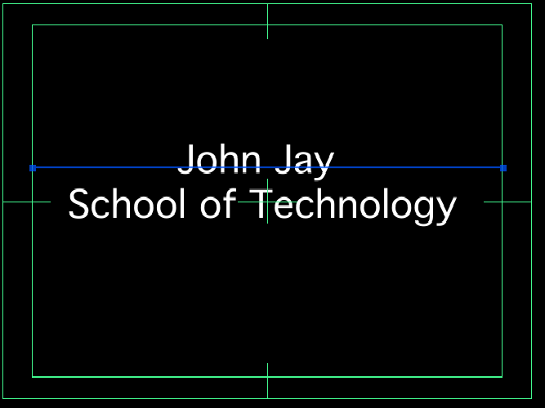

Changing Font Style of Text
There are two types of fonts in LiveType. One is the regular system fonts (mac fonts) and the other are font specific to LiveType (live fonts).

To change the font style:
Click the FONT TAB of the Media Browser Pallet and select the Family & Typeface. After previewing the font choose Apply.


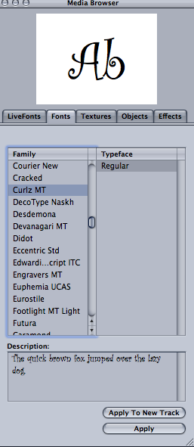
← Media Browser
FONT TAB
Updated Canvas
↓

Using Pre-Rendered LiveFonts:
In the LIVEFONTS tab of the Media Browser Pallet you can select a pre-rendered font. You cannot change those attributes of the fonts, since the font designer rendered each character separately. When you find the desired LiveFont, you can apply that font by selecting Apply.


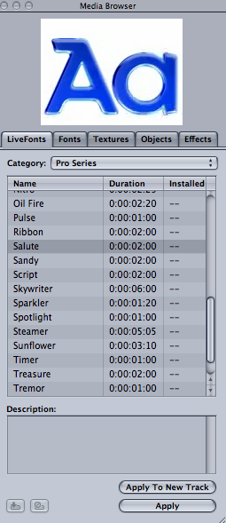
← Media Browser
LIVEFONTS TAB
Updated Canvas
↓

Changing Style and Attribute of Text
In LiveType you can change the Text Attributes by selecting the STYLE tab of the Inspector Pallet.

With your text selected you can stylize your text by adding shadows, glows, outlines, and extruding your text. You can also change the font color, and scale your text by selecting the ATTRIBUTES tab in the Inspector Pallet window.

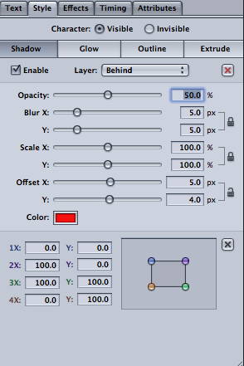

Applying Your Knowledge

In LiveType make a new canvas. Name this file as __ __ (first & last initial) Activity1, and SAVE this file in your Activities folder located in your Project V folder.

After Completing Activity 1, you would:
- Change the Background color of your Canvas
- Add your First and Last name in the Canvas
- Adjusted the Size, Leading, and Tracking of your Text
- Added a Track Curve
- Changed the Font Style (using Mac Font)
- Changed the Attributes & Style of Text

When Complete, call instructor over for approval:

_________

