Name: ________________________________________ Semester: __________ Period:____

Introduction:
In Web Design, you have various clients who have different needs that require different designs. You will be selecting three different client ideas from the list below, and you will create a navigation layout for each of your three clients. You will sketch out in color, each of the three clients you chose. You will eventually use Adobe Photoshop to bring your ideas to life on the computer.

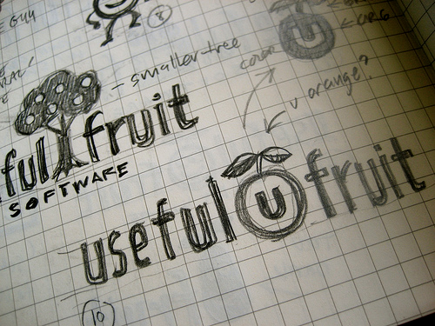
Directions:
Step One
- Choose any three ideas for clients on the list below:
  - Bosco’s Dairy Farm
  - Aunt Jane’s Nostalgic Candy Supply
  - Noah’s Ark Daycare
  - O’Malley’s Irish Pub & Grill
  - Arrow Amusement Park Concession Supply
  - Haunted Forrest Hayrides
  - Billy Goat Lawn Care
Step Two
- In the boxes below, sketch out your three selected designs from the clients listed above:
Design I: ____________________
Design II: ____________________
Design III: ____________________

Step Three
- In Adobe Photoshop, use your sketches (from step two) and design a basic navigation design.
  - Dimensions (pixels) 800W x 200H, 72PPI, RGB
- Save these PSD files in a newly created Resources folder.
- Save each layout as separate files in your Resources folder

Step Four
- Format these newly created Photoshop layouts as .jpg’s (File →Save for Web & Devices) and save them in a newly created images folder.
- Create a new Text Wrangler Document and save it as Lesson_6.html document.
- Using your previous knowledge from HTML, create your new Lesson 6 page to show your three navigation layouts.
- Print your coding and finished layout (webpage) from your web browser.

