Name(s):___________________________________ Semester:_____________ Period:______

___________________________________

Directions:
You will be reporting a story to that will air on MSG Varsity channel 14/ 614 and On-Demand 714. You may choose any topic of your choice to broadcast, but all stories and topics must be approved by your instructor. Remember all stories must contain an interview, b-roll, and added audio narration which will be recorded separately in the audio mixing room. You may work with ONE other student.

Jay News Now - Reporting Ideas

- Preview of an upcoming event
- Profile of a Team Captain
- Profile of a Star Performer
- Alumni Profile
- Facility Profile
- Athlete of the Week/Month
- Student of the Week/Month
- Dances or Social Events
- App-Wrap (Application Review)
- Automobile Review
- Car Care Tips
- Pet Pointers
- “How To” Video
- Sports Highlight
- Weekend Buzz
- Strength Training
- Healthy Eating
- Club Hosted Special Events
- The School Building
- Easy Meals
- Overview of a new product
- Product Comparison
- Senior Spotlight
- Club Feature
- Course Feature
- Holidays or Monthly Events
- Weekend Getaways
- Politics
- Healthy Living
- Home Maintenance
- Performing Arts
- College Preparation
- Choose your own!
- Coping with Weather
- Coping with Stress
- Safety Video
- Information about a lesser known sport or club


Step One: Project Brainstorming & Contract

Topic Idea:
_________________________________________________________________________________________________

Why did you choose this topic?
__________________________________________________________________________________________________________________________________________________________________________________________________

When does your event take place?
_________________________________________________________________________________________________

Who are the main point contacts and their contact information for your story?
_________________________________________________________________________________________________
_________________________________________________________________________________________________

Who are you going to interview for your story, and when are your interviewees available?
_________________________________________________________________________________________________
_________________________________________________________________________________________________

What interview questions are you going to ask your interviewee?
_________________________________________________________________________________________________
_________________________________________________________________________________________________

What type of B-Roll needs to be shot for your project?
_________________________________________________________________________________________________
_________________________________________________________________________________________________

Is there anything you need from your instructor to complete this project?
_________________________________________________________________________________________________
_________________________________________________________________________________________________

Instructor Approval: ______________________
Student Signature: ______________________
Due Date: ______________________

Step Two: Make a New Project Folder and Set Up Final Cut Pro □
- On your computer, MAKE A NEW FOLDER in your Communication Systems folder titled your initials_JNN_project name (example: jb_JNN_HudsonValleyGolfing).
- Open, Save, and Set-Up Final Cut Pro (FCP). Even though you will not be using FCP for a while, it’s a good idea to be set to go when you get to import your media as soon as you shot.
- Create a New Project File, Save your new FCP project file as your initials_JNN_project name in your newly created JNN project folder (from step one).
- Scratch your disk, allowing FCP to save media files in your newly created project folder. (Refer to “Getting Started in Final Cut Pro” for help)
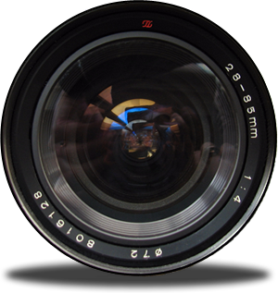
Instructor Approval: ______________________

Step Three: Equipment Sign-up & Sign-out □
Congratulations! Now it’s time to have fun shooting. Make sure you follow classroom guidelines for signing out equipment and returning cameras with accessories in the proper working condition the following morning before the start of the school day. Keep track of your camera make, model, and number.

Step Four: Import Media to FCP □
After you finished shooting, you will import all media into Final Cut Pro. Make sure you dump all your footage into FCP immediately, so your classmates can sign-out and utilize the camera and accessories.

Step Five: Developing, Recording, and Adding Narration □
Refer back to your “Reporter’s Questions” from Step One and your review your video footage to type out a narration of your story. Once you type out your narration, you may use the sound mixing room to record your audio. Upon recording your audio narration, you will save your narration in your JNN project folder, and then import your audio narration into FCP.
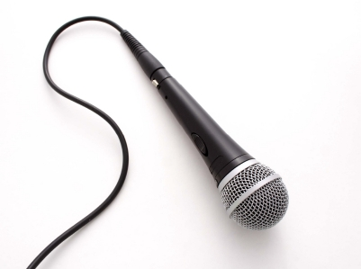
Instructor Approval: ______________________

Step Six: Cut, Place, and Sequence Video □
In FCP you will label and organize your newly imported clips. You will complete the following:
- Label all clips in the clip bin
- Mark-in and mark-out points
- Place clips in your final video sequence

Step Seven: Add Special Effects & Transitions □
You will be adding transitions and special effects to your video clips. Feel free to Google tips and tricks in this area.
Step Eight: Text, Titles, Credits □
Any text should be added in this step. Feel free to download fonts. Your credits should include, your name(s), John Jay High School (East Fishkill, NY) Communication Systems, Semester, and all cast, characters, location info.
Step Nine: Music and Audio Effects □
Add all audio, including SoundFx and background music. Remember it’s easier to work with audio when you are finished editing your video tracks. Make sure you add your music source info to your credits (Step Eight).

Instructor Approval: ______________________

Step Ten: Export □
Save this project and EXPORT this video project in QuickTime format and name your project the same name as your video. Your final exported video should be saved in your JNN Project folder.

Step Eleven: File Share □
File share your team’s final project’s QuickTime video to JJ-167-TEACHER or transfer on the instructor’s USB Flash Drive in the appropriate folder.

JNN Project Grading Rubric:

 | 0 Point  Unsatisfactory effort, does not utilize skills learned, weak, no proof of skill/missing, must improve, seeking extra help is encouraged. | 1 Point  Satisfactory effort, few skills learned or applied, needs to improve and try harder for next project, student should seek extra help. | 2 Points  Good effort, applied and utilized skills learned in class, creativity is present, but not to full capacity. | 3 Points  Excellent effort, above average, knowledge of skill is evident, understands and applies skills learned in class.
Project Planning
Topic Choice
Project Summary (Reporter’s Questions)
Interview Questions
B-Roll List
Video Quality
Steady Shots
Camera Moves
Audio Narration
Shot Composition
Audio Levels
Video Graphics
Credits
Exported As QuickTime
The Story
Story Covered
Professional Interview
Titles
Audio Levels
TOTALS:
 |  |  | PROJECT TOTAL: | ___ /48 x 2 = ___/98

