Name:_________________________________________ Date:____________ Period:_______

Heat Transfer Vinyl
T-Shirt Design Project


School Functions

 Businesses


College & University


Party & Events

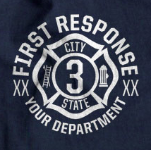
Fire Departments


Holiday Events

Directions: Using your previous knowledge of Computer Graphics, Principles and Elements of Design, and Adobe Illustrator, you will be designing a one color single design T-Shirt.

Step One: Idea Sketches
- Sketch FOUR different T-Shirt design ideas below
- Utilize the entire box
- Yes, you must have four different ideas!
- Add Color to enhance your design

Sketch #2

#2

Sketch #1

Sketch #3
Sketch #4

STOP!
Instructor Must Sign Off Before Moving Forward

Instructor Approval

Step Two: Mechanical Layout
- Draw your top designs on the T-Shirt template below
- Try to be precise as possible
- List details about font styles and stroke weighting
- Write are the dimensions of your shirt and design
- Add Color to enhance your design

Mechanical Layout
Side: Front Back

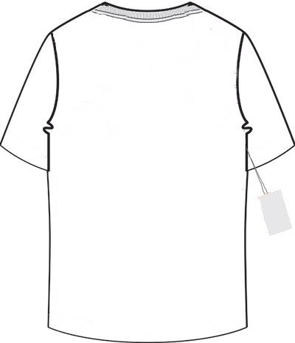

STOP!
Instructor Must Sign Off Before Moving Forward

Instructor Approval

Step Three: Shirt Specifications
- What color shirt will your be printing on? __________________________________________

- What is the material composition of you shirt? _____________________________________

- What color heat transfer vinyl are you using? ______________________________________

- What is the size of your overall design (width & height) in inches? ______________________

STOP!
Instructor Must Sign Off Before Moving Forward

Instructor Approval

Step Four: Start Adobe Illustrator
- Make a new project folder in your Computer Graphics folder titled (first & last initial) t_shirt_design (ex: jb_t_shirt_design)
- Set up your new document properties (size and orientation) based off your design size.
- Begin Designing
- Utilize fonts, templates, and free vector art.
- No Copyrighted logos or images

Step Five: Submit File for Cutting
- Submit your project folder to John Jay Completed drive.
- Make sure you include fonts and other supporting files in your submitted project folder

Step Six: Cutting, Weeding, and Pressing
- Mr. Butler will work with you on cutting your t-shirt design
- Weed out the unwanted vinyl from your cut design
- Pre-Press shirt to remove wrinkles
- Align design on shirt
- Press design on your shirt

*************************************** GRADING *****************************************

Four Idea Sketches Layouts (4 points each) ______/16

Mechanical Layout Design ______/10

Shirt Specification Accuracy ______/8

Adobe Illustrator Page Setup ______/10

Quality and Difficulty of Design ______/10

File Structure ______/6

Quality of Weeding, Placing, and Pressing ______/10

Total: ______/70

