Notebook/Portfolio Organization (Assignments)

Communication Systems
John Jay High School

Department of Technology Education Mr. Butler

Name:_________________________________________ Date:____________ Period:_______

Directions: You will be creating Notebook Dividers for your course binder/portfolio. These dividers will help keep your work and course content organized. Using Microsoft Word, create the following cover pages for your notebook. Use your own creativity. Remember pages will be printed black & white on colored paper.
Page 1
Page 2

Your Name

Communication Systems

Fall 2013

Instructor: Mr. Butler

Lab #167

Class Notes

Page 3
Page 4

Assignments

Activities

Lessons

Projects

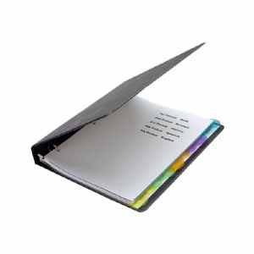

Tests & Quizzes

Page 5

