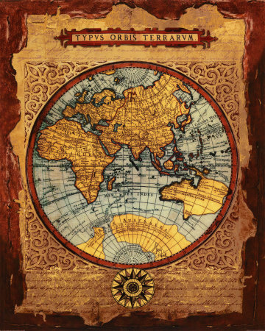

Introduction
Welcome to 9th grade Global History! Together, we are about to embark on a journey to understand how different cultures have developed. This course covers roughly the time period beginning in Pre- history- 4000B.C. E. through 1750 C.E. During this school year you will be gaining the knowledge and skills necessary to advance to the next stages of the Global History curriculum.

Materials
- 3 ring binder (1 1/2inch)
- Divider Tabs which should be labeled as follows:
  - One Pagers
  - Quizes & Tests
  - Maps
  - Timeline
- Loose-leaf paper (200 sheets at least)s
- Pens, pencils and highlighters, colored pencils

How to Succeed in 9th Grade Global
If you come to class with a positive attitude, complete your work with care, participate in class, and ask for extra help when needed, you will do well in this course.

Expectations
- Be on time - you should be in your seat and ready to work by the time the bell rings.
- Be prepared -You must be prepared to work. This includes having a pen or pencil and your notebook every day.
- Late homework will NOT be accepted. Students with legal absences will have until the following Friday to complete missed assignments and class work. You are responsible for finding out what work was missed by looking in the folder at the front of the class.
  - Projects and essays will be accepted late but will be penalized 10 points per day.
- Quizzes. Fridays are happy dance, pizza movie milkshake, quiz day. If you are absent Friday, expect to take the quiz the first day you return to school.
- Quiz and Test Corrections – will be accepted for half credit. Test corrections must be handed in by the Friday following the return of the quiz/test.
- Cheating will not be tolerated. If suspected of cheating, you will receive a zero on the assignment and your parent and/or guardian will be contacted immediately!
- No Electronic Devices. They will be confiscated.

**We respect the thoughts and opinions of others! Always treat others as you would want
them to treat you!!! Put downs and negative comments will NOT be tolerated. Welcome new ideas. Be kind and considerate.
Extra Help
I encourage you to come see me if you have any problems, questions, or concerns. I am at school by 6am and stay until 3pm most days. My free periods are 1st and 4th and I can be found in room 223. If you are not able to come by at those times, you may email me at: elizabeth.scheffel@wcsdny.org with questions or concerns.

Grading Policy:
- Quarterly grades are determined as follows
  - Tests, essays, DBQs, (50) quizzes 30 points) group work, class assignments and notebook checks done quarterly (20 points)
- The district wide final is worth 20% of your overall grade.

Global 9 Course Outline (D347): Below is a rundown of the topics we will be covering over the course of the year
.

Introduction to the “Pre-Civilization” World
- Map Reading Skills
- The Continents and Oceans
- Reconstructing the Past
- Paleolithic and Neolithic People
First Civilizations
- Characteristics of Civilization
- Egypt
- Mesopotamia
  - From City-States to Empires
  - Judaism
- India
  - Cities and Kingdoms
  - Belief Systems
- China
  - The Early Dynasties
  - Belief Systems
Mediterranean Civilizations
Ancient Greece
- People of the Aegean Sea
- Hellenic Greece
- Accomplishments
- The Hellenistic Age
Ancient Rome
- The Roman Republic
- Christianity and The Roman Empire
- Accomplishments
- Fall of Rome and the Byzantine Empire
The Muslim World
- The Islamic Faith
- The Spread of Islam
- Golden Age of Islam
- The Ottoman Empire
Kingdoms of the Americas and Africa
- Meso-America
- Incan Civilization
- African Geography and Culture
- Kingdoms and Trade Routes

Empires of East Asia
- China
- Korea
- Japan
- Southeast Asia
Middle Ages of Europe
- Western Europe
- Eastern Europe
- Religion and Conflict
- Advancements
- Crisis in the Middle Ages
The Rise of Modern Europe
- The Renaissance and Reformation
- Why Italy?
- Northern Europe
- Early Religious Reformers
- Spread of the Reformation
- Results: Science and Exploration
European Colonization
- Asia Encounters Europe
- The Americas Encounter Europe
- African Encounters
- Effects on Europe
Age of Absolutism
- Spain
- France
- England

